# **AI ASSISTED CODING**

**ASSIGNMENT-4.4**

# Name:S.Vrindha Reddy

HALL NUMBER:2403A51264

BATCH:11

# Task-1:

Write a class definition comment and start the constructor for a class called Bank Account with account_holder and balance attributes. Use GitHub Copilot to auto-complete the rest of the class, including methods to deposit, withdraw, and display balance.

# Output:

Task-2:

Write a comment and the initial line of a loop to iterate over a list. Allow GitHub Copilot tocomplete the logic to sum all even numbers in the list.

**Code:**

# Output:

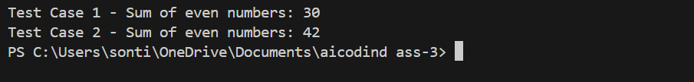Task-3:

Start a function that takes age as input and returns whether the person is a child, teenager, adult, or senior using if-elif-else. Use Copilot to complete the conditionals.

**

Output:

**Task-4:**

Write a comment and start a while loop to reverse the digits of a number. Let Copilot complete the loop logic.

**Output:**

**Task-5:**

Begin a class Employee with attributes name and salary. Then, start a derived class Manager that inherits from Employee and adds department. Let GitHub Copilot complete the methods and constructor chaining.

**Output:**

